Below is the request which we have received this time, and it has been came from Bresler Retha.

This is Monthly activity and need to be performed in the starting of the month for the last month.
We have to perform this activity by 1 week of the month, otherwise the GDG generation will get deleted.
We need to look into the file CFGIBS.LA00.XXX.ACCNTSRT and it contains all the information.
We have to copy production file CFGIBS.LA00.XXX.ACCNTSRT, means all GDG for the last month into IPS.PO0144G1.RPS.ACCNTSRT.OCT2023. Here OCT2023 file will get created in the starting of the Nov 2023 and it will contain information for Oct 2023.
How to created new month IPS.PO0144G1.RPS.ACCNTSRT.OCT2023 file.
First open the latest file and provide option I Infront of the file and press enter and then come out. Below is the screen shot for reference.
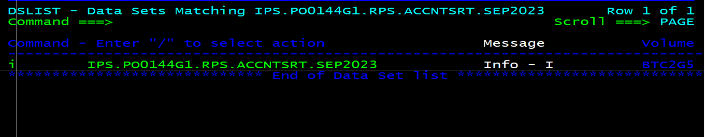
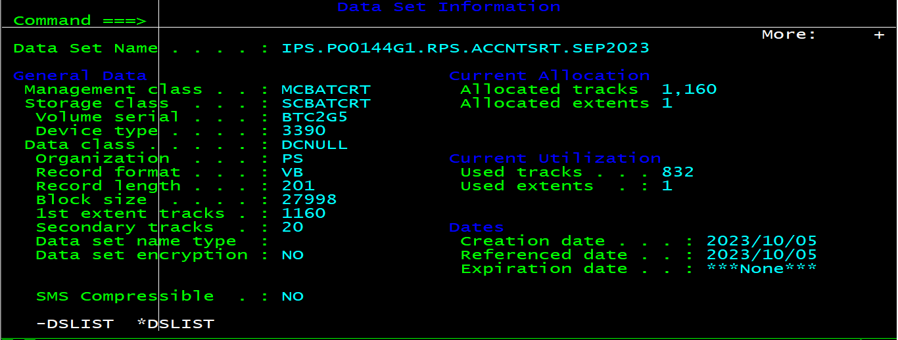
Now select option 7.3.2 and provide the below information into it and then press enter. Below is the screen shot for future reference.
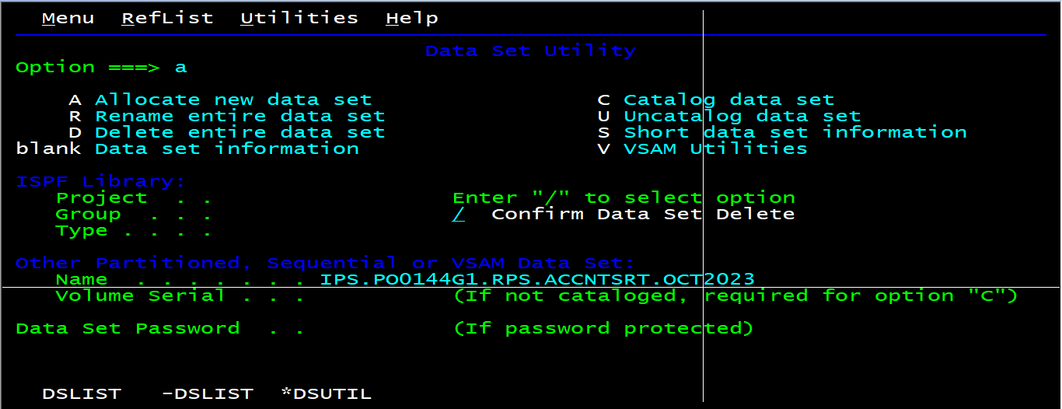
As we have press I next to the older file it will take all the properties of it automatically on the next screen. Below is the screen shot for the same.
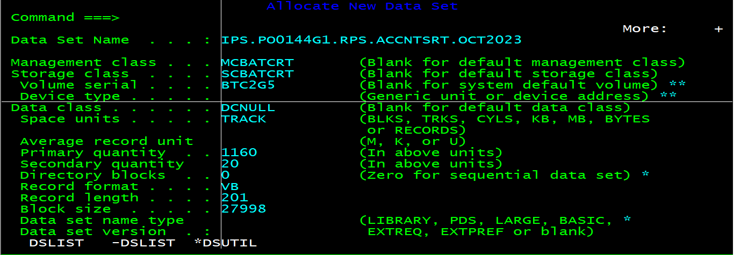
Now just press ENTER and it will create the new file.
Now we have to copy all the GDG versions for that month into IPS file and to perform this activity we will go to FileAid.
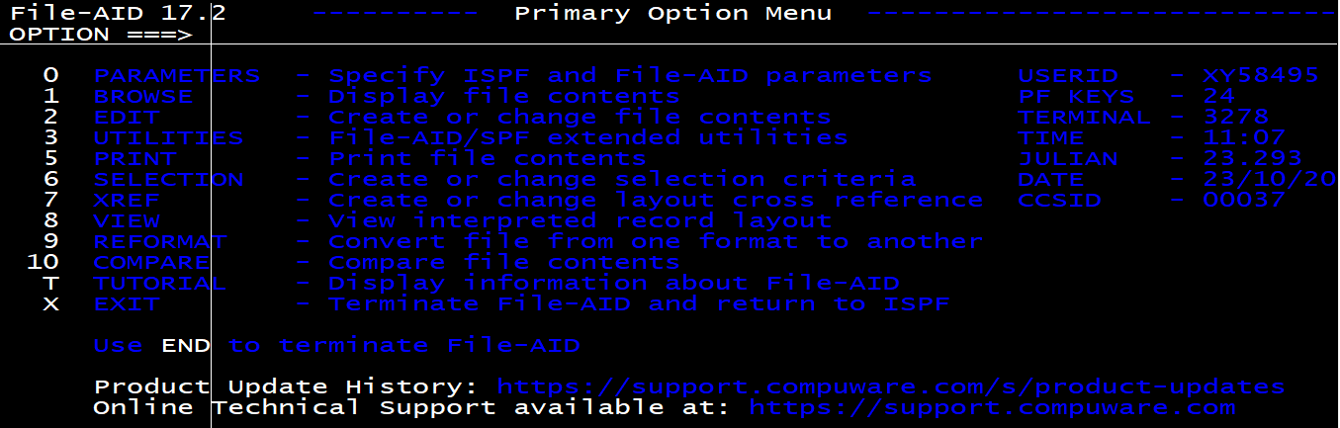
Now we have to select option 3 from the above screen.
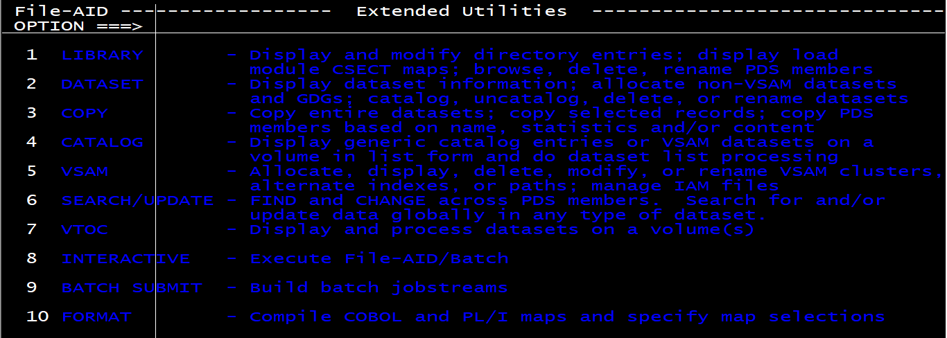
Now again from this screen as well we have to select option 3 and then we will see below screen.
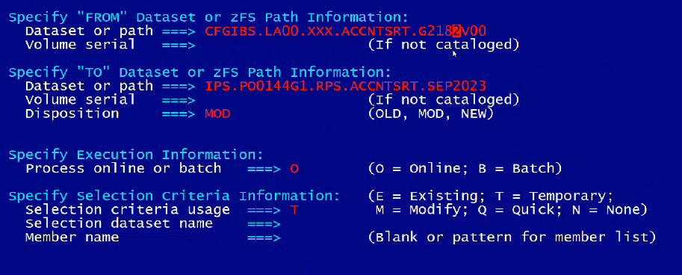
Now into above screen we have first pass the GDG version of the first day of the month and press ENTER. After that it will get copied into the IPS file.
Same process we have to follow for all GDG’s of that month, once all the files will get copied it means that it has all the accounting history or records for that month. But it is not into readable format.
To convert the file into readable format we have to send file into TSOA with the same name but just changed the first qualifier from IPS to ISD.
We will be doing this activity at the end of the quarter only for the last three month and at that point of time only we will send files into TSOA.
Now we have to run the job ISD.PO0144G1.KLBRPS.JCL(ACCNTEXT), below is the screen shot of the job.
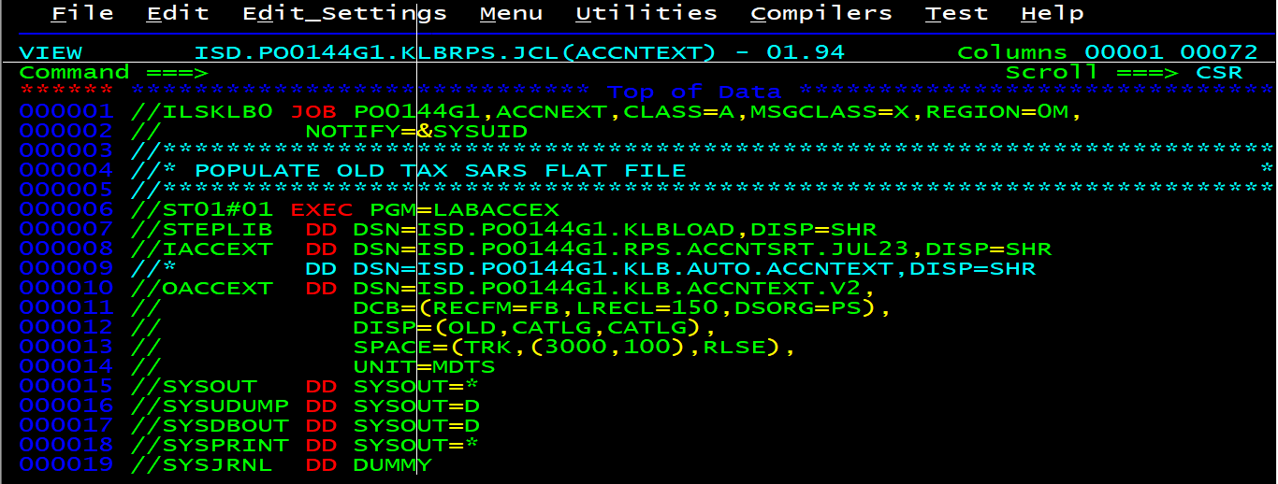
We have to provide input file name one by one for the month in the below line of the job.
//IACCEXT DD DSN=ISD.PO0144G1.RPS.ACCNTSRT.JUL23,DISP=SHR
At the end it will create the comma delimited file with name ISD.PO0144G1.KLB.ACCNTEXT.V2.
Now we have to send this file on the server into .TXT format. Below is the screen shot for drop location and file naming conventions.
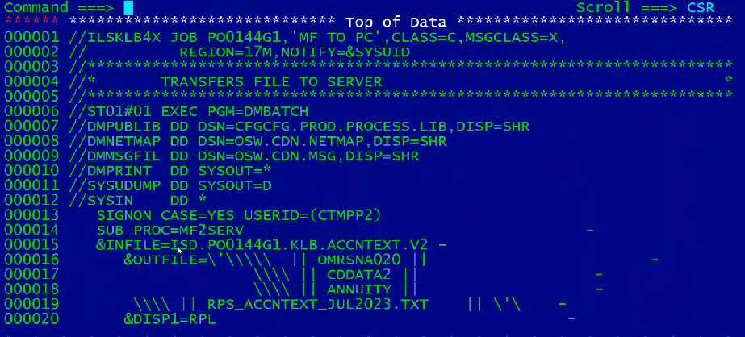
Now we have to repeat the same process for other two months as well.
At the end we have to store these files into below share drive path for future reference.
Z:\CB&A_Programme\07 Annuities System\Reports\Accounting reports\Auditors
Then we have to go to the Deloitte audit side https://deloitteconnect.deloitte.com and upload the file there in the folder they have told us.
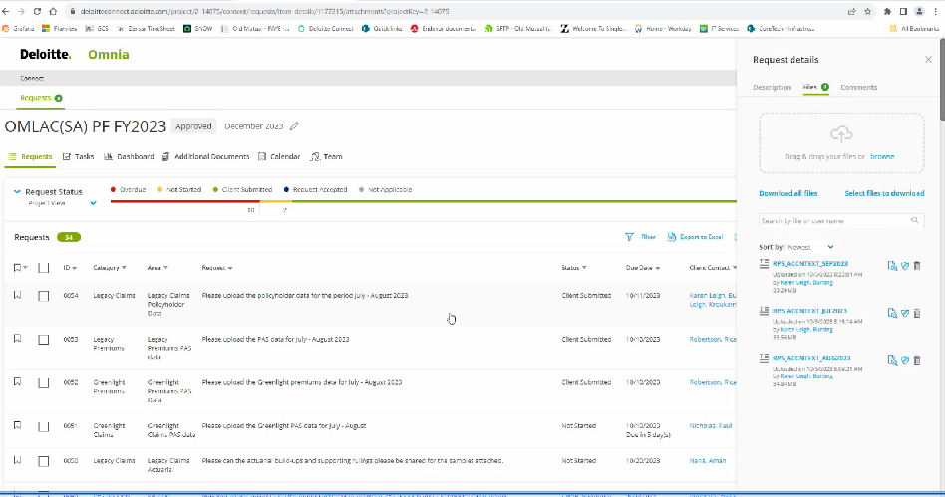
Below is the mail which we can send to get the Deloitte audit side access https://deloitteconnect.deloitte.com .

